**Wake On LAN over Internet**

For turning on the computer in shut down state it should have a active power supply and a Ethernet connection always

And then by sending a Magic packet to the computer it can be turned on through the UDP protocol

Step1:- Turn on wake on LAN in BIOS

Step2:- In Ethernet properties -> configure -> Power Management ->

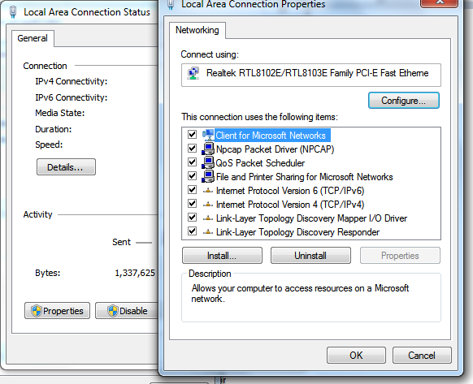

1. keep both options turned on

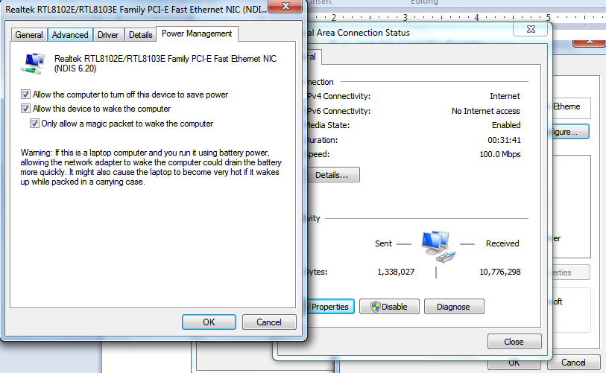

ii) In Advanced -> Wake on Magic Packet -- Enabled

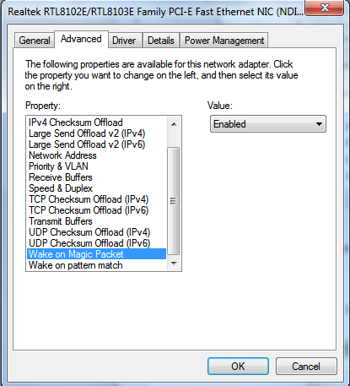

Now wake on LAN is enabled in the local network

Download this application given below:-

<https://play.google.com/store/apps/details?id=co.uk.mrwebb.wakeonlan>

select LAN address in that in local address it will turn on

For over internet

Turn on your router Port forward   
Port forward at port 🡪 9

On the required IP address of the computer

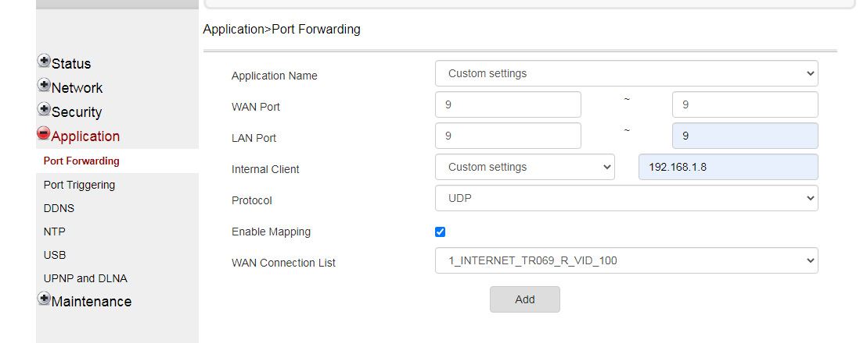

After Port forward, using your router

Using these information’s

Primary DNS

MAC Address

Subnet and

Port = 9

Download either mobile app (apk) or the UI app from given link

You can Turn on the computer over the internet by sending the Magic packet

https://drive.google.com/drive/folders/1E5KByg1CAeDV0RSdzNsL7HDrB6NZgz7v?usp=sharing

